**FINRA Rule 6151 Order**

**Routing Information Filing Guide**

Version 1

**Contents**

1. **Introduction ........................................................................................................................ 4**
2. **FINRA Entitlement Program ................................................................................................. 5**
3. **File Upload Specifications: Introducing Firm Clearing Firm Relationship ................................ 6**
4. **File Upload Specifications: 606 Reports ................................................................................ 7**
5. **File Transfer via Machine-to-Machine .................................................................................. 8**
6. **File Upload via FINRA Gateway ............................................................................................ 9**
   1. **Uploads ......................................................................................................................... 10**
      1. **Upload Files ................................................................................................................... 11**
      2. **Upload File History ........................................................................................................ 11**
      3. **File Feedback ................................................................................................................. 12**
7. **Uploaded File Validation, File Feedback ............................................................................. 13** **7.1.** **Rule 606(a) File Upload Validations, File Feedback .......................................................... 13**

**7.1.1.** **File Responses ............................................................................................................... 13**

**7.1.1.1.** **Sample Response File Names ..................................................................................... 13**

**7.1.2.** **Validations and Corresponding Feedback File ................................................................. 13**

* 1. **Clearing Firm Relationship File Upload Validations, Feedback File: .................................. 16**

1. **Support Links .................................................................................................................... 17**

**Document Version History**

|  |  |  |
| --- | --- | --- |
| **Date** | **Version Number** | **Description** |
| 3.22.2024 | 1 | Initial Publication |

# Introduction

The FINRA Rule 6151 Order Routing Information Filing document provides a guide for member firms who are required to submit to FINRA for centralized publication the order routing reports required under the Securities and Exchange Commission’s SEC Rule 606(a).

To upload Rule 606(a) Reports, member firms will need to complete the entitlement process for accessing FINRA’s systems (refer to Section 2 for more information). Once processed, firms may upload documents through the FINRA Gateway user interface (refer to Section 6 for more information) or via a direct machine-to-machine file transfer (refer to Section 5 for more information). Once the reports are submitted, firms will be notified of the file upload status (refer to Section 7 for more information).

For information on FINRA Rule 6151 and additional requirements visit [FINRA Communication Hub.](https://www.finra.org/filing-reporting/rule-6151-reporting-compliance)

Rule 606(a) reports submitted to FINRA will be published in the FINRA Data Portal.

# FINRA Entitlement Program

[FINRA Entitlement Program](https://www.finra.org/filing-reporting/entitlement) is the process by which firms are granted secure access to participating FINRA web applications.

A firm will require a FINRA Entitlement account and a designated [Super Account Administrator](https://www.finra.org/filing-reporting/entitlement/super-account-administrator-saa) (SAA) to submit Rule 606(a) reports using FINRA’s systems.

For [FINRA Gateway,](https://ews.finra.org/auth/logon?realm=ews&goto=https://gateway.finra.org/app?rcpRedirNum=1) refer to the SAA link above on how to get entitlements/account access. In the case of machine-to-machine file uploads (using [fileX)](https://www.finra.org/filing-reporting/data-transfer-tools/fileX), the firm is required to reach out to the [FINRA support group](https://www.finra.org/filing-reporting/entitlement/ftpift-users) (or via telephone at (800) 321-6273 ) to create/modify user accounts as well as grant entitlements.

For SAA and machine-to-machine access, firms must:

* Complete the [FINRA Entitlement Agreement (FEA)](https://www.finra.org/sites/default/files/finra_entitlement_agreement_fea.pdf)
* Complete the [New Organization SAA Form](https://www.finra.org/filing-reporting/entitlement-program/new-organization-saa-form)

Once FINRA approves access, the organization’s SAA will receive entitlements, which they can grant to other users in the organization, or a machine account will be created by the FINRA Entitlement team.

The entitlement details are as follows:

* Entitlement: SEC Rule 606 NMS Reporting
* Entitlement description: Will allow approved users to upload Rule 606(a) reports through fileX or via the UI in FINRA Gateway

For support, please refer Section 8

# File Upload Specifications: Introducing Firm Clearing Firm Relationship

The following section contains reporting requirements for member introducing firms that, pursuant to existing SEC guidance, route all their customer orders to one or more clearing firms for further routing and execution and adopt such clearing firm’s Rule 606(a) reports by reference.

These member introducing firms are required to (i) submit to FINRA a comma separated values (CSV) file that lists its clearing firm(s) along with a web link to a webpage where the member introducing firm discloses its clearing firm relationship(s) and adopts the clearing firm’s reports by reference and (ii) update the submission if the information previously provided changes. Please note, this CSV is a one-time submission, only requiring subsequent file submission in case a member introducing firm needs to update the information previously provided to FINRA.

This CSV file submission will be subject to the same publication requirement as Rule 606(a) report submissions, i.e., the CSV file must be submitted within one month after the end of the calendar quarter addressed in the report.

While the clearing firms will have to submit Rule 606(a) reports to FINRA, the introducing firms are responsible for ensuring proper and timely submission of said reports.

The clearing firm relationship CSV file must contain the following details:

- CSV file name format o *Intro firm crd number*_606_NMS_ clearing_Firm_Details.csv

▪ Sample file name: 12345_606_NMS_clearing_Firm_Details.csv - CSV Required fields.

o clearing Firm CRD o Weblink to the intro firm clearing firm relationship.

Sample Clearing Firm relationship CSV contents:

4567,https://firm123.com/disclaimer-link

1634,https://firm123.com/disclaimer-link

9367,https://firm123.com/disclaimer-link

# File Upload Specifications: 606 Reports

Uploads must consist of Rule 606(a) reports in two formats: PDF and XML. If a member firm submits a subsequent Rule 606(a) report for the same reporting period, the subsequent Rule 606(a) report will replace the previously submitted Rule 606(a) report.

A user should use the following naming template for a Rule 606(a) Report file that will be uploaded to FINRA.org:

* *firm CRD number_606_NMS_YYYY_Qn.PDF*
* *firm CRD number_606_NMS_YYYY_Qn.XML*

Refer [Order Routing & Handling Schema Tech Spec](https://www.sec.gov/files/order_handling_data_technical_specification-2020-12-19.pdf) for technical specifications on Rule 606(a) PDF, XML reporting requirements

The following information is required on the Rule 606(a) report for both PDF and XML formats:

* Firm CRD number for whom the report data applies.
* Quarter + year (YYYY_Qx) for which the report data applies.
* An optional suffix (_<suffix>) if desired
* Mention of ‘606’ to identify files as being 606 reports.
* Include NMS to identify 606 NMS reports.
* An optional suffix can be added after the quarter.

Sample file names:

* 12345_606_NMS_2024_Q1.PDF
* 12345_606_NMS_2024_Q1.XML
* 4567_606_NMS_2023_Q4_20240108.XML

Note: For information about what rules/restrictions apply to the filename, refer to section 7, FAQ 5 of the [fileX User Guide.](https://www.finra.org/filing-reporting/data-transfer-tools/fileX)

# File Transfer via Machine-to-Machine

For IP whitelisting and other instructions/information on machine-to-machine transfers using fileX, refer to the [fileX User Guide.](https://www.finra.org/filing-reporting/data-transfer-tools/fileX)

For the list of validations performed on Rule 606(a) Reports, error codes, and feedback files on successful/failed file upload, refer to section 7.

# File Upload via FINRA Gateway

Accessing FINRA Gateway to upload Rule 606(a) reports requires [multi-factor authentication](https://www.finra.org/filing-reporting/multi-factor-authentication) using DUO Mobile. This applies only to Super Account Administrators (SAA), Account Administrators (AA). A brief tutorial is available from the login screen. If a user has any difficulties with their FINRA login, please reach out to the respective firm's Super Account Administrator for assistance.

1. To access FINRA Gateway, click on the link below:

<https://gateway.finra.org/>

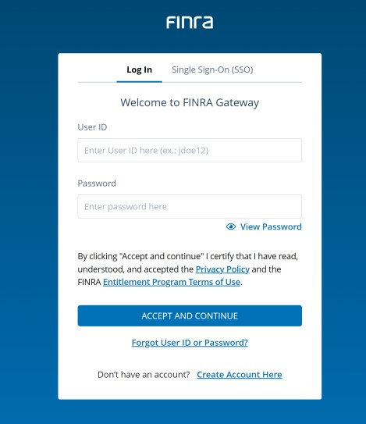

1. On the left navigation, there are shortcuts to the features in FINRA Gateway. Navigate to Upload Files section.

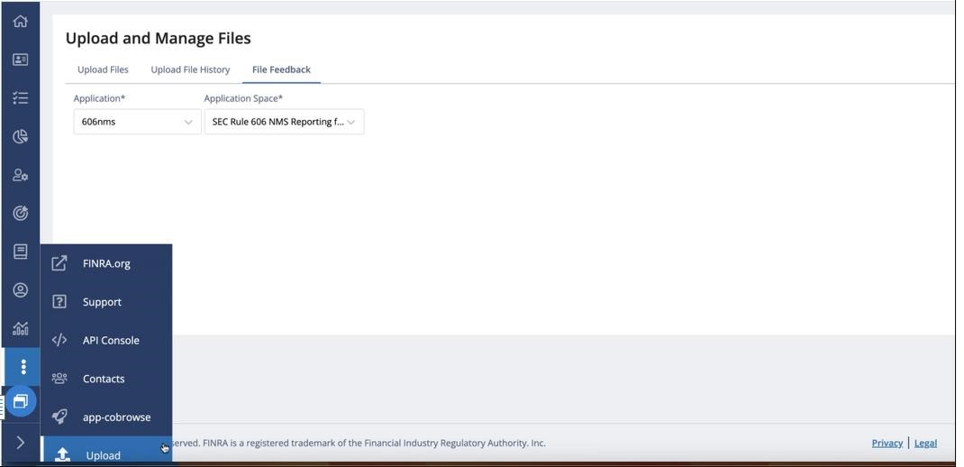

1. Select the following from Application, Application Space Application: 606nms

Application Space (entitlement name): SEC Rule 606 NMS Reporting

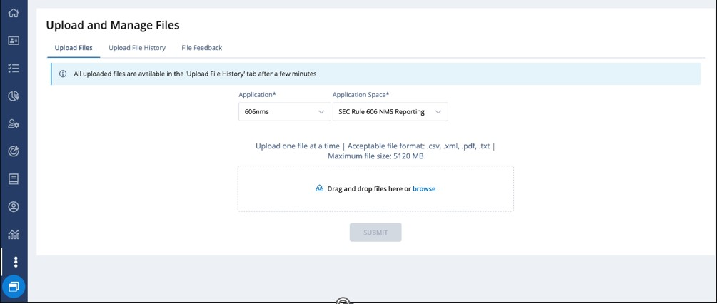

**6.1. Uploads**

There are three tabs under Uploads:

1. Upload Files
2. Upload File History
3. File Feedback (covered in section 7)

* 1. **Upload Files**

To upload Rule 606(a) Reports in FINRA Gateway, either drag and drop them into the dotted area or select and upload them by clicking on **Browse** -> **Select File** -> **SUBMIT**.

Once the file has been uploaded, you will receive a pop-up message on the right corner of the Dashboard:“File was uploaded successfully. View Upload File History.”

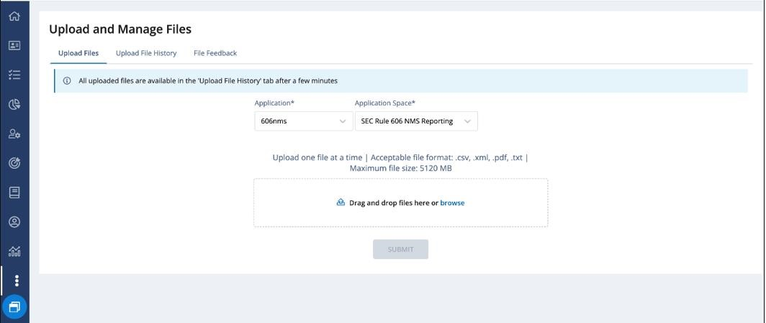

* 1. **Upload File History**

All uploaded files are available in the “Upload File History” tab. You can find the File Name, File Upload Date, File Size for uploaded files, and use the tool tip to show the status for each uploaded file.

Uploaded files can be downloaded by clicking on the “Download” icon.

Files in the Upload File History directory will be stored for up to a period of 30 days.

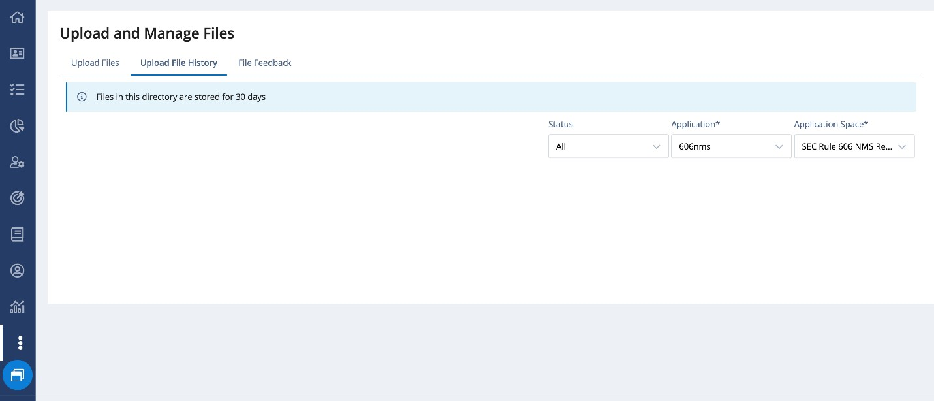

The possible list of statuses can be viewed by hovering over the tooltip next to the Status columns.

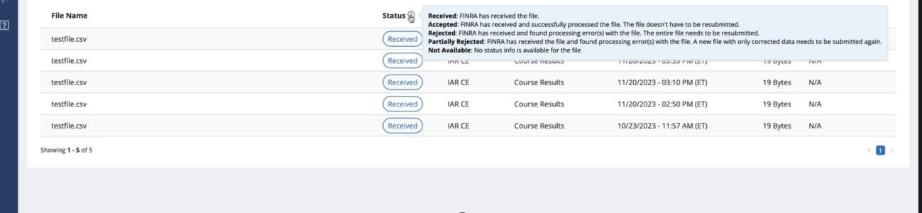

* 1. **File Feedback**

File Feedback includes files with processing results for the Rule 606(a) Reports file uploaded. To verify that the file upload was successful or to view the error message(s) for a rejected file, download the feedback file by clicking on the “Download” icon.

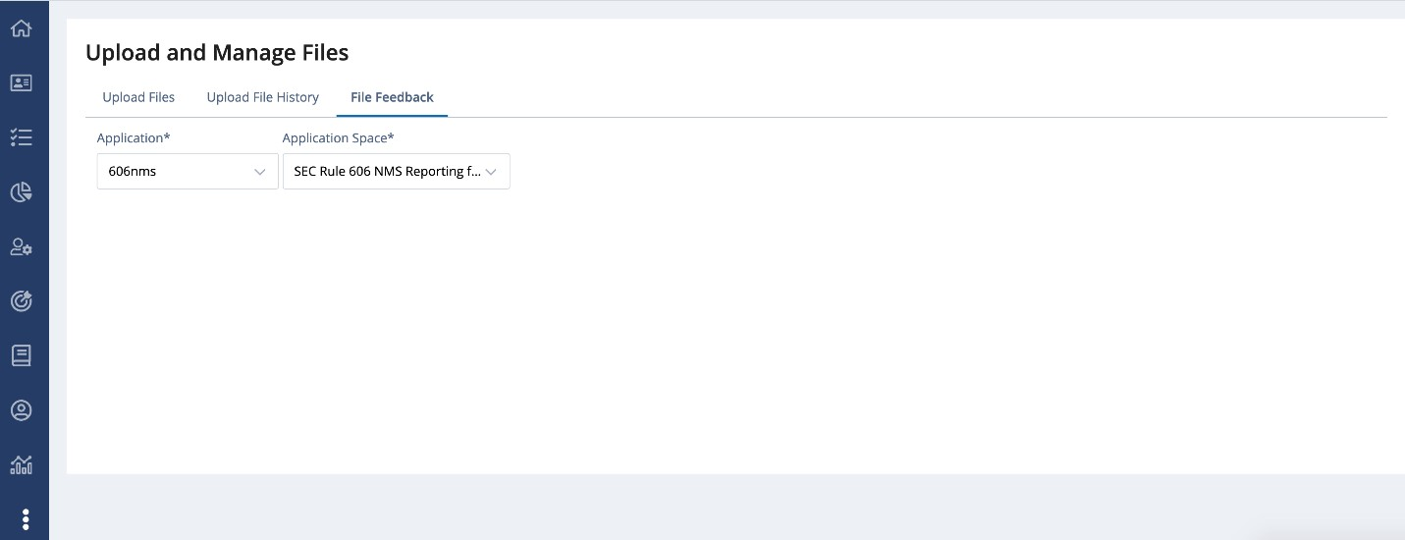

For the list of validations performed on Rule 606(a) Reports, error codes, and feedback files on successful/failed file upload, refer section 7.

# Uploaded File Validation, File Feedback

**7.1. Rule 606(a) File Upload Validations, File Feedback**

Upon submitting SEC Rule 606(a) Reports using either FINRA Gateway or machine-to-machine, a feedback file will be provided indicating a successful or failed file upload.

**7.2. File Responses**

The following format will be used to create file/content acceptance/rejection files in response to the uploaded 606 reports.

* File acceptance o <Original File Name>.ts<posix formatted file receipt timestamp>.fileaccept.csv
* File/Content rejection o <Original File Name>.ts<posix formatted file receipt timestamp>.reject.csv

**7.3. Sample Response File Names**

PDF

* *7890 _606_ NMS_YYYY_Qn.PDF*.ts1682913600.fileaccept
* *7890 _606_ NMS_YYYY_Qn.PDF*.ts1682913600.reject.csv

XML

* *7890_606_ NMS_YYYY_Qn.XML*.ts1682913600.fileaccept
* *7890_606_ NMS_YYYY_Qn.XML*.ts1682913600.reject.csv

**7.4. Validations and Corresponding Feedback File**

Upon Rule 606(a) Report submission, users will receive a feedback file indicating whether the file was accepted or rejected.

Section 7.2.1 contains a list and a brief explanation of error codes associated with file rejections. These error codes will be provided in the reject feedback file (csv), covered in Section 7.2.2. Section 7.2.3 includes a sample feedback file (csv) for successful Rule 606(a) Report upload.

**7.4.1.1. Sample Feedback**

|  |  |  |  |  |  |  |
| --- | --- | --- | --- | --- | --- | --- |
| **Nb** | **Error Code** | **Applicable to** | **Brief Explanation** | **Warning/**  **Error** | **pdf/xml** | |
| 1 | INVALID_PDF | File  Feedback | Invalid pdf | ERROR | pdf |  |
| 2 | INVALID_FILE_NAME | File  Feedback | Error code is generated when file format is invalid, file name contains a future review period, file format is not PDF/XML | ERROR | pdf xml | & |
| 3 | INVALID_CRD_NUMBER | File  Feedback | Error code is generated when the CRD in the filename is invalid. This can happen when the CRD number does not exist or when it is not valid for at least one day during the given review period. | ERROR | pdf xml | & |
| 4 | INVALID_ XML | Content Feedback | Failed to parse input file content. All the standard XML handling will be part of this error | ERROR | xml |  |
| 5 | DUPLICATE_RECORD | Content Feedback | Error code is generated when the XML data is Repetitive Monthly data for <MMYYYY> | ERROR | xml | |

**Rejected Feedback File**

If the uploaded Rule 606(a) Report is rejected, the user will receive a rejection file (csv) with one or more error codes and corresponding error messages indicating the reason.

**Sample Rejected File Name Format**

* PDF: 7890 _606_ NMS_YYYY_Qn.PDF.ts1682913600.reject.csv
* XML: 7890_606_ NMS_YYYY_Qn.XML.ts1682913600.reject.csv

**Sample Error Message(s) for Error Code**

1. Example 1
   * 1. Error code: INVALID_FILE_FORMAT
     2. File Name : 7890 _606_ NMSS_YYYY_Qn.XML
     3. Rejection Feedback File:
     4. Sample Error Message(s):

i. File format of the file submitted doesn't match the Expected format (CRD_606_ NMS_YYYY_Qn.XML)

1. Example 2
   * 1. Error code: INVALID_REPORTING_PERIOD
     2. File Name: 7890 _606_ NMS_2023_Q4.PDF
     3. Sample Error Message(s):

i. Year format of the file submitted doesn't match the Expected format (CRD_606_ NMS_YYYY_Qn.XML)

1. Example 3
   * 1. Error code: INVALID_CRD
     2. File Name: **780**_606_ NMS_YYYY_Qn.PDF
     3. Sample Error Message(s):

i. CRD Number of the file submitted doesn't match the Expected format (CRD_606_ NMS_YYYY_Qn.XML)

1. Example 4
   * 1. Error code: INVALID_XML
     2. File Name: 7890_606_ NMS_YYYY_Qn.XML
     3. Sample Error Message(s):
        1. The value '0.00' of element 'netPmtPaidRecvNonMarketableLimitOrdersCph'is not valid
        2. Invalid content was found starting with element

'netPmtPaidRecvMarketOrdersUsd'. One of '{otherPct}' is expected

1. Example 5
   * 1. Error code: DUPLICATE_RECORD
     2. File Name: 7890_606_ NMS_YYYY_Qn.XML
     3. Sample Error Message(s):

i. Repetitive Monthly data for <072023>

**Sample Reject Feedback File**



**Accepted Feedback File**

PDF: 7890 _606_ NMS_YYYY_Qn.PDF.ts1682913600.fileaccept.csv

XML: 7890 _606_ NMS_YYYY_Qn.PDF.ts1682913600.fileaccept.csv

**7.5. Clearing Firm Relationship File Upload Validations, Feedback File:**

*Introducing Firm/Clearing Firm Relationship CSV validation information will be shared in a later version of this FINRA Rule 6151 Order Routing Information Filing Guide.*

# Support Links

• The [FINRA Support Center](https://www.finra.org/filing-reporting/entitlement/ftpift-users) can be contacted using the following:

* Email: FINRASupportCenter@finra.org
* Telephone: (800) 321-6273